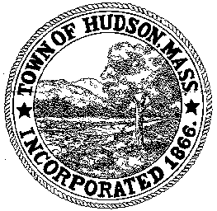

CONSERVATION COMMISSION
78 Main Street, Hudson, MA 01749
(978) 562-2020

Paul Byrne, Chairman W. Minot Wood, Vice Chairman David Esteves, Member

Terrence Joyce, Member Leif Longtine, Member Joseph Rodrigues, Member Al Tashian, Member

Meeting Agenda
November 15, 2012 7:00 P.M.

- Preliminaries
  - Open Meeting
  - Roll Call

2.0 New Business
2.1 DEP 190-0
Applicant: Thomas Cullen, Marlborough DPW
Location: 61 Brook Street
Project Description: restoration of a stream bank which was eroded due to a breach of an upstream beaver dam.

2.2 Enforcement Order
A&D Ferrecchia LLC
Tree cutting

2.3 Minutes: November 1, 2012

2.4 Correspondence

2.5 Commission / Assistant issues

3.0 Adjournment

